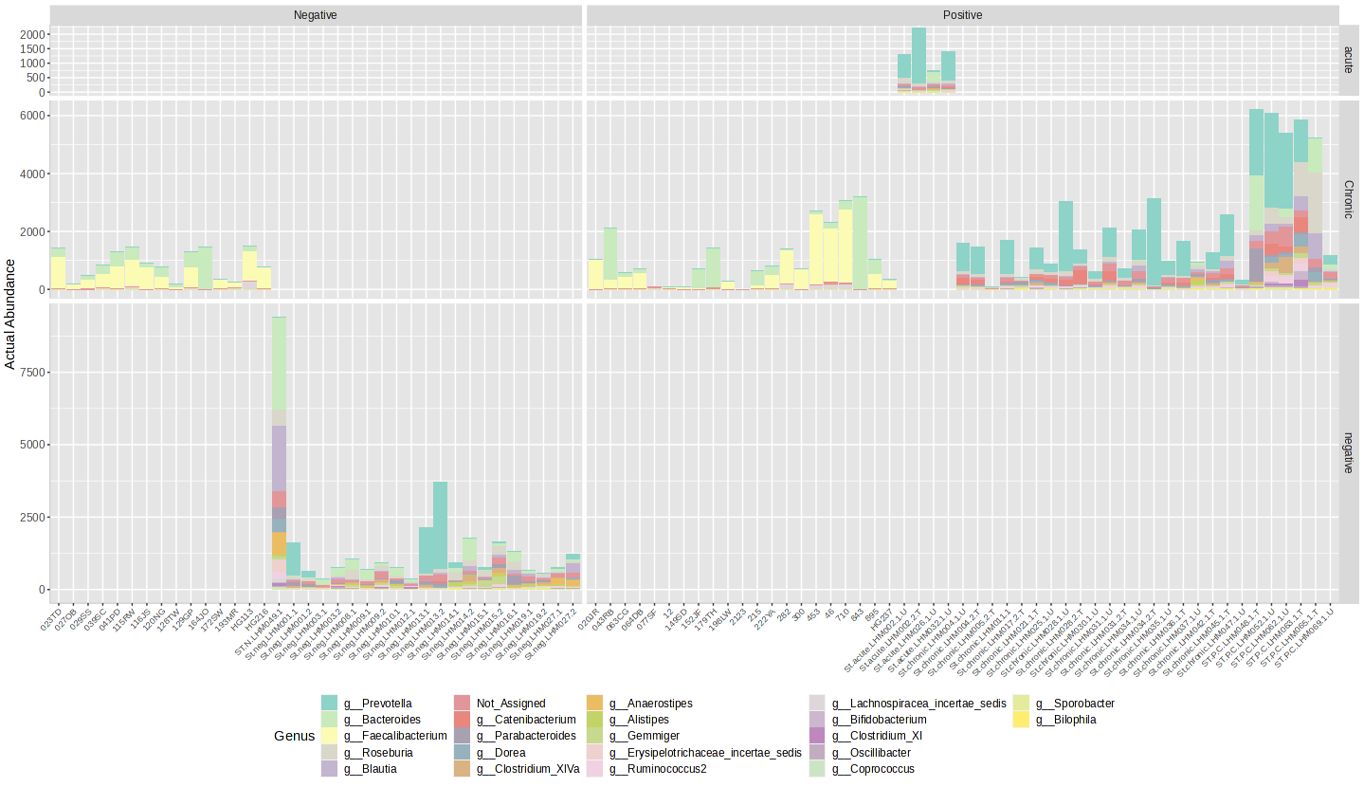
Figure S1. The abundance of species among HIV uninfected and infected individuals.

A | B
C | D
E

Figure S2. Alpha diversity among HIV uninfected and infected individuals, including (A) Shannon index, (B) Simpson index, (C) Chao1 index, (D) Fisher index, (E) The principal coordinates were separated effectively based on differences in ASVs (e.g., Catenibacterium) in HIV-infected individuals.

A
B
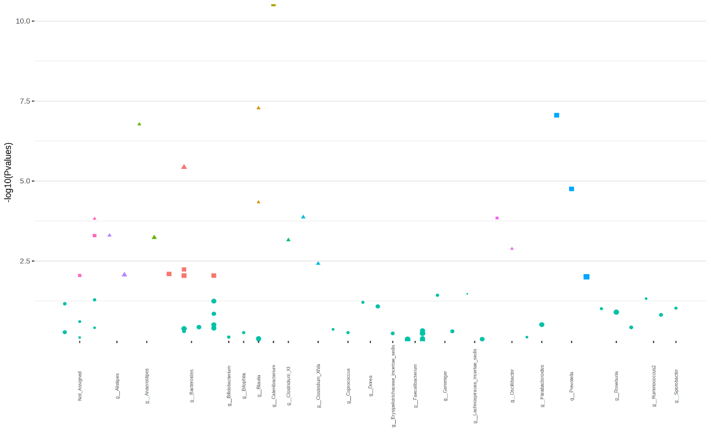
Figure S3. Prevalence of microbiomes (A) and their changes (B) in HIV uninfected and infected individuals. Statistical method “EdgeR”, Adjusted p-value cutoff =0.05.
A
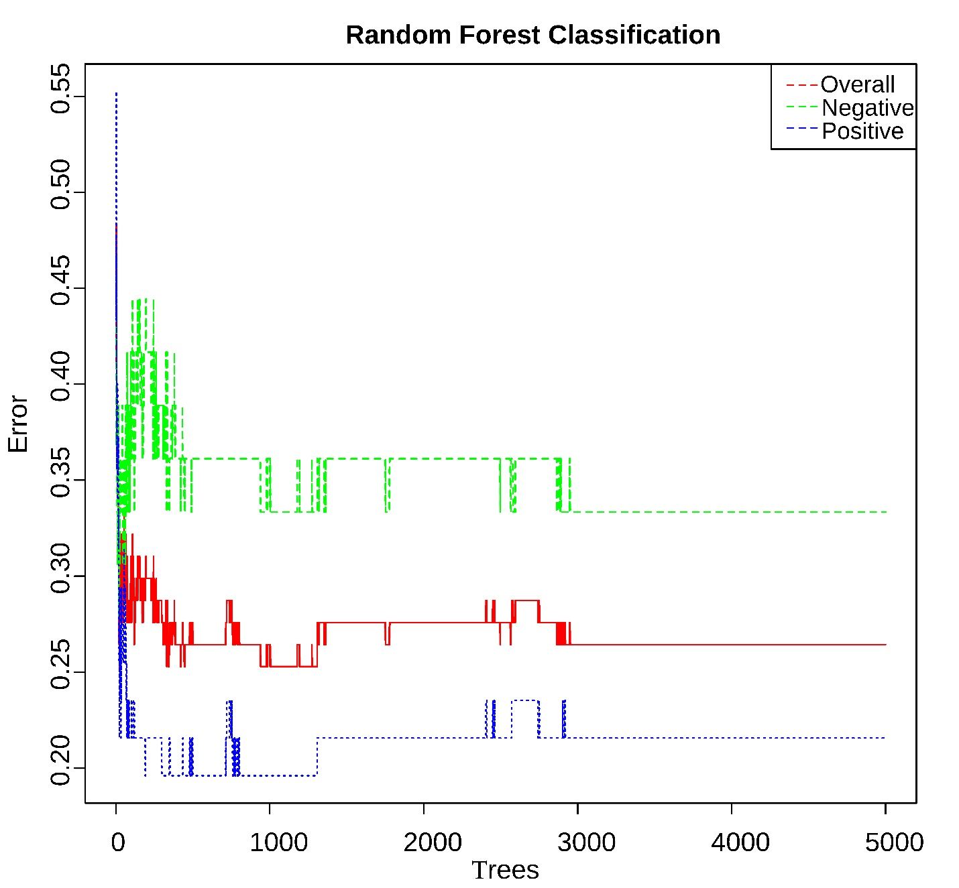
B

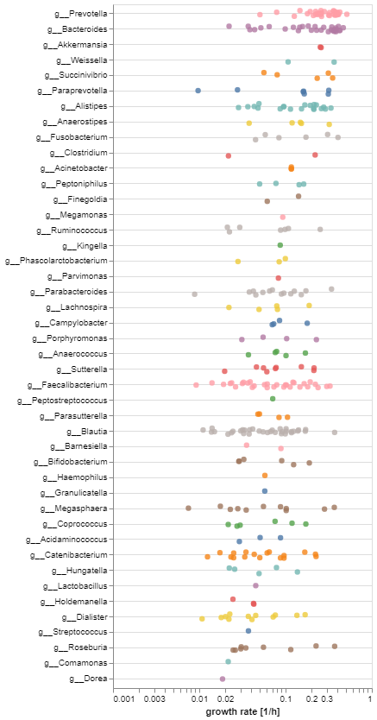
Figure S4. (A) A random forest model determines the essential aspects of ASV abundances in the microbiome of both HIV-infected and HIV-negative individuals. The model had an out-of-bag (OOB) error rate of 2.64% for the entire dataset. (B) Growth rate of microbiome in HIV infected and uninfected individuals using MICOM model.
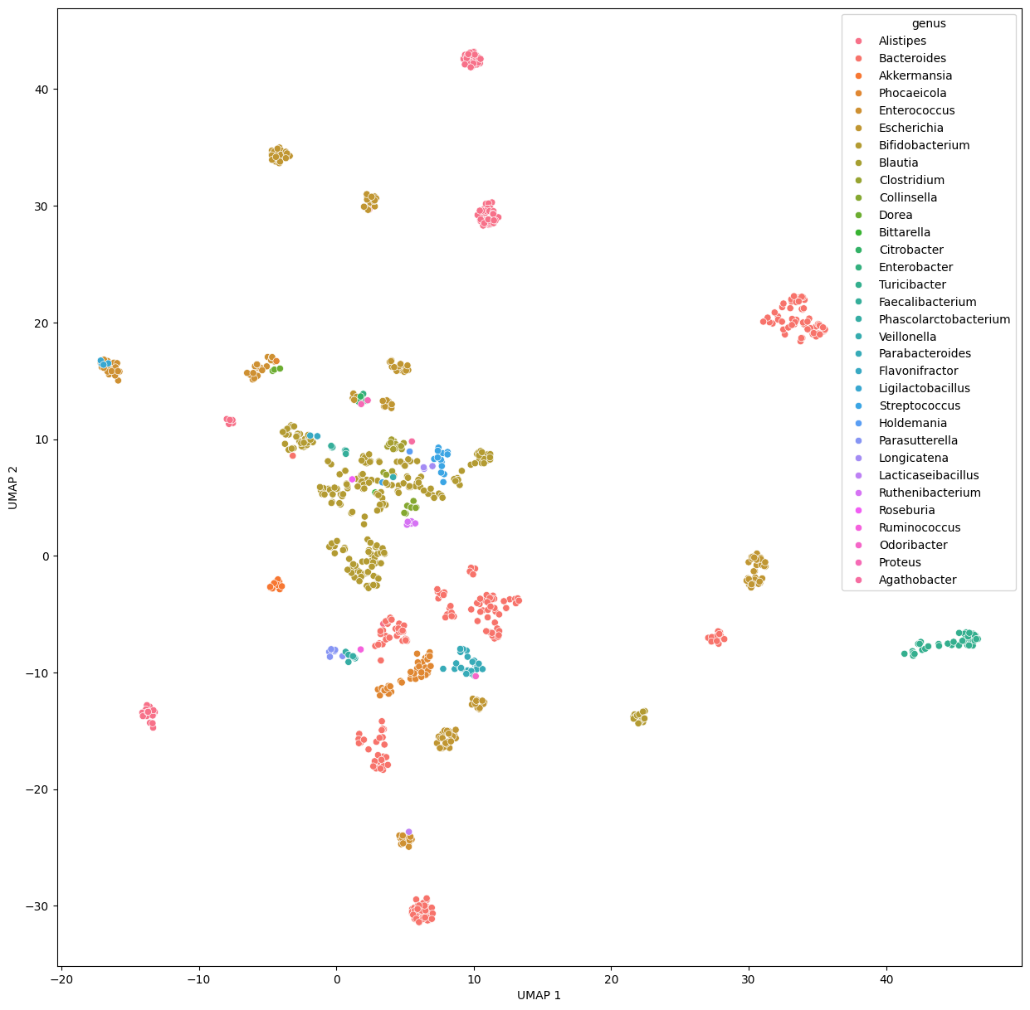
Figure S5. Interactions between microbiomes in HIV infected and uninfected individuals (PERMANOVA (pseudo-F) = 73.180, R²=0.712, p-value= 0.001).

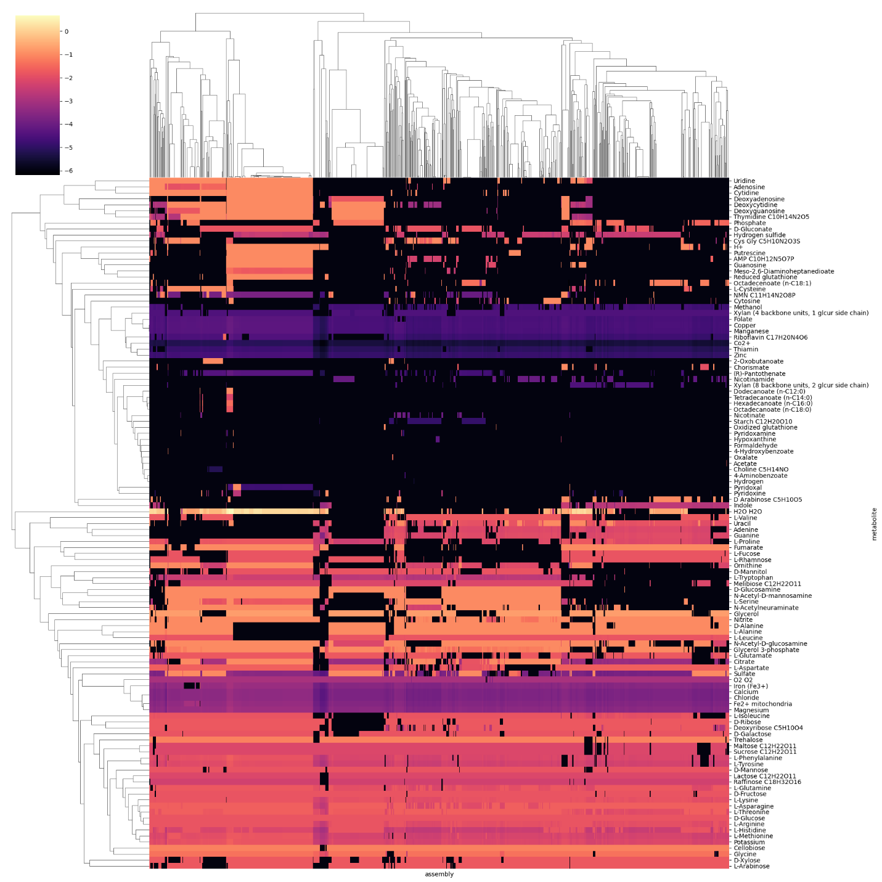
Figure S6. Metabolites in HIV infected and uninfected individuals.

Figure S7. Top 70 metabolites with the highest MESs in HIV infected and uninfected individuals.

Figure S8. Top metabolites with high metabolite exchange scores in HIV infected and uninfected individuals.

Figure S9. Metabolite exchange score in HIV infected and uninfected individuals (Mann-Whitney p-value < 0.0351). *<0.05; **<0.01, ***<0.0001

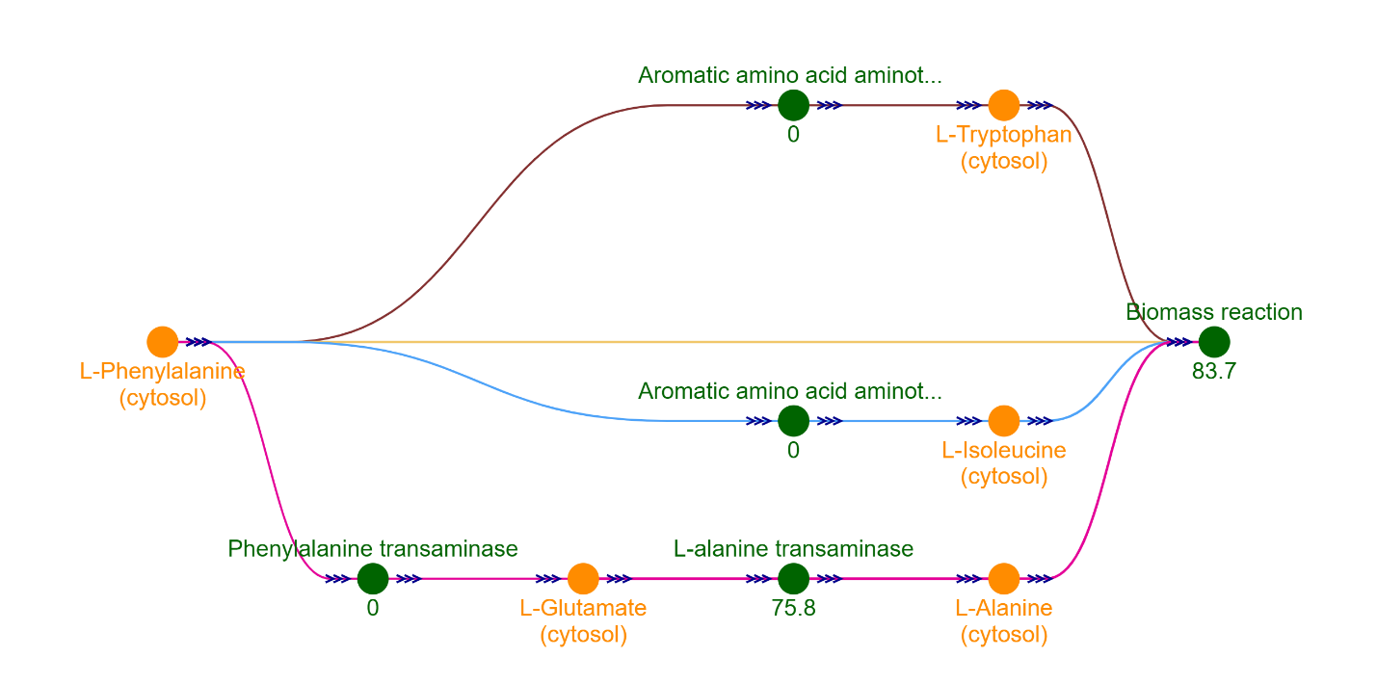
Figure S10. The flux of k-shortest paths in a metabolic model of L-phenylamine in the cytosol.

